**Assignment 1**

**Experiment 1 and 2**

**Title: ANN and Its Models**

Name of Student: Sangeet Agrawal PRN No. 21070122140

DoP1: 15 Jul

DoP2: 22 Jul DoS: 28 Jul

**Aim:**

**a)** Implement a Program to Generate the Output of Logic AND Function by McCulloch–Pitts Neuron Model. The Threshold on Unit Is 2. Simulate same by changing T = 1

**b)** Implement a Program to Generate Output for OR Function Using McCulloch–Pitts Neurons with Threshold Value 1

**c)** Implement a Program to Generate Output for XOR Function Using McCulloch–Pitts Neurons with Threshold Value 1

d) Implement a Program to Generate Output for ANDNOT Function Using McCulloch–Pitts Neurons

**Learning Outcome:**

1. To understand the fundamentals of ANN

2. To implement McCulloch–Pitts Neuron Model

**Hardware/Software:** Google Collab

**Problem Statement:** X1=[1 1 0 0], X2=[1 0 1 0] T=2, w1=1, w2=1

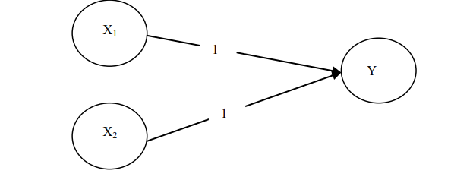

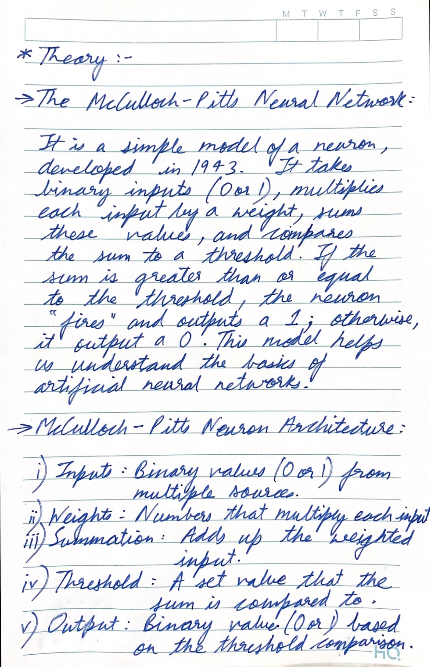

**Program a)**

| # AND Function  def mcCulloch_pitts_and_t1(inputs):  # Adjusted weights for AND function  weights = [0.5, 0.5]  threshold = 1   # calculate the weighted sum  weighted_sum = sum(weight * input_val for weight, input_val in zip(weights, inputs))   # apply the threshold to get the output  output = 1 if weighted_sum >= threshold else 0  return output  def mcCulloch_pitts_and_t2(inputs):  # weights for AND function  weights = [1, 1]  threshold = 2   # calculate the weighted sum  weighted_sum = sum(weight * input_val for weight, input_val in zip(weights, inputs))   # apply the threshold to get the output  output = 1 if weighted_sum >= threshold else 0  return output  # Test inputs test_inputs = [(0, 0), (0, 1), (1, 0), (1, 1)]  print("\nAND Function with T = 1") for inputs in test_inputs:  print(f"Inputs: {inputs} -> Output: {mcCulloch_pitts_and_t1(inputs)}")  print("AND Function with T = 2") for inputs in test_inputs:  print(f"Inputs: {inputs} -> Output: {mcCulloch_pitts_and_t2(inputs)}") |
| --- |

**Output Screenshot:**

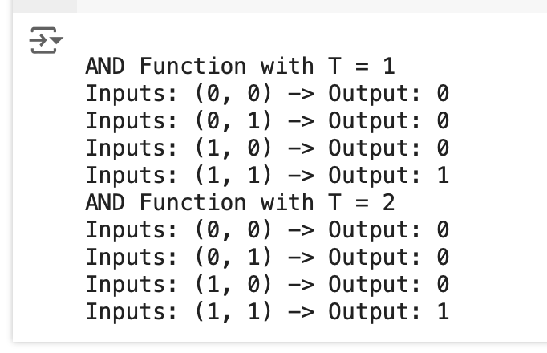

**Program b)**

| # OR Function  def mcCulloch_pitts_or(inputs, threshold):  # weights for OR function  weights = [1, 1]   # calculate the weighted sum  weighted_sum = sum(weight * input_val for weight, input_val in zip(weights, inputs))   # apply the threshold to get the output  output = 1 if weighted_sum >= threshold else 0  return output  # Test with threshold T = 1 threshold_1 = 1 test_inputs = [(0, 0), (0, 1), (1, 0), (1, 1)]  print("OR Function with T = 1") for inputs in test_inputs:  print(f"Inputs: {inputs} -> Output: {mcCulloch_pitts_or(inputs, threshold_1)}") |
| --- |

**Output Screenshot:**

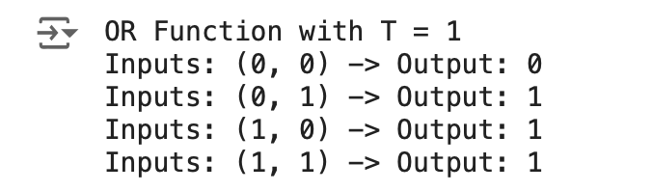

**Program: c)**

| # XOR Function  def mcculloch_pitts_neuron(inputs, weights, threshold):  weighted_sum = sum(w * i for w, i in zip(weights, inputs))  return 1 if weighted_sum >= threshold else 0  def xor_mcculloch_pitts(x1, x2):  # Neuron 1 (OR gate)  n1_output = mcculloch_pitts_neuron([x1, x2], [1, 1], 1)   # Neuron 2 (AND gate)  n2_output = mcculloch_pitts_neuron([x1, x2], [1, 1], 2)   # Neuron 3 (XOR gate)  xor_output = mcculloch_pitts_neuron([n1_output, n2_output], [1, -2], 1)   return xor_output  # Test the XOR function print("XOR Function Outputs:") for x1 in [0, 1]:  for x2 in [0, 1]:  print(f"XOR({x1}, {x2}) = {xor_mcculloch_pitts(x1, x2)}") |
| --- |

**Output Screenshot:**

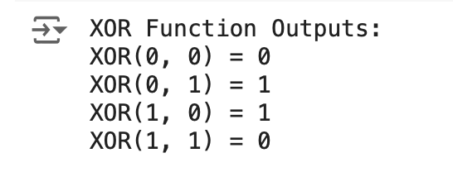

**Program d)**

| # NAND Function  def mcCulloch_pitts_nand(inputs):  # Weights for NAND function  weights = [-1, -1]  threshold = -0.5   # Calculate the weighted sum  weighted_sum = sum(weight * input_val for weight, input_val in zip(weights, inputs))   # Apply the threshold to get the output  output = 1 if weighted_sum >= threshold else 0   return output  # Test inputs test_inputs = [(0, 0), (0, 1), (1, 0), (1, 1)]  print("\nNAND Function:") for inputs in test_inputs:  print(f"Inputs: {inputs} -> Output: {mcCulloch_pitts_nand(inputs)}") |
| --- |

**Output Screenshot:**

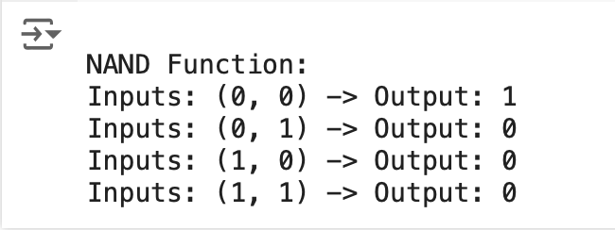

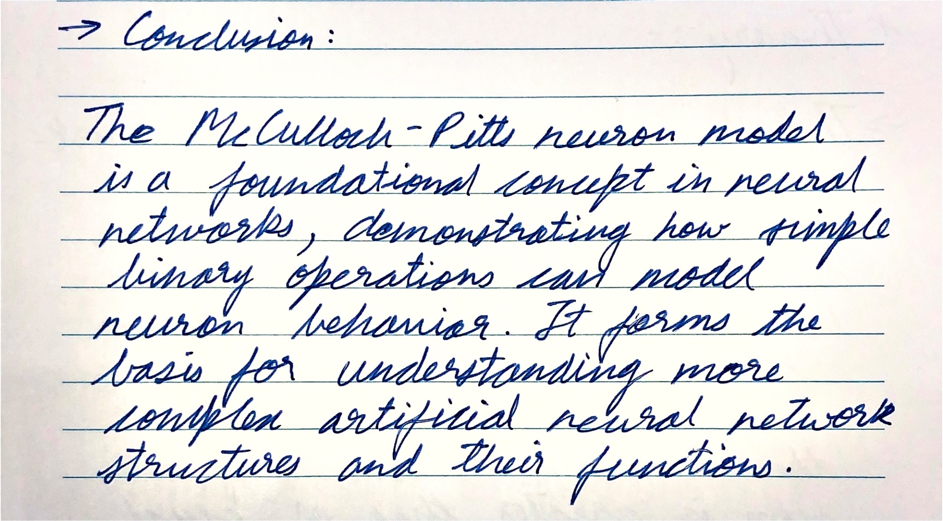

**Assignment 1**

**Experiment 3**

**Title: ANN and Its Models**

Name of Student: Sangeet Agrawal PRN No. 21070122140

DoP: 29 Jul DoS: 4 Aug

**Aim: e)** Implement activation functions Binary unipolar, binary bipolar, continuous unipolar, sigmoid, and ReLU function

**Learning Outcome:**

1. To understand the fundamentals of ANN

2. To implement McCulloch–Pitts Neuron Model

**Hardware/Software:** MATLAB Online

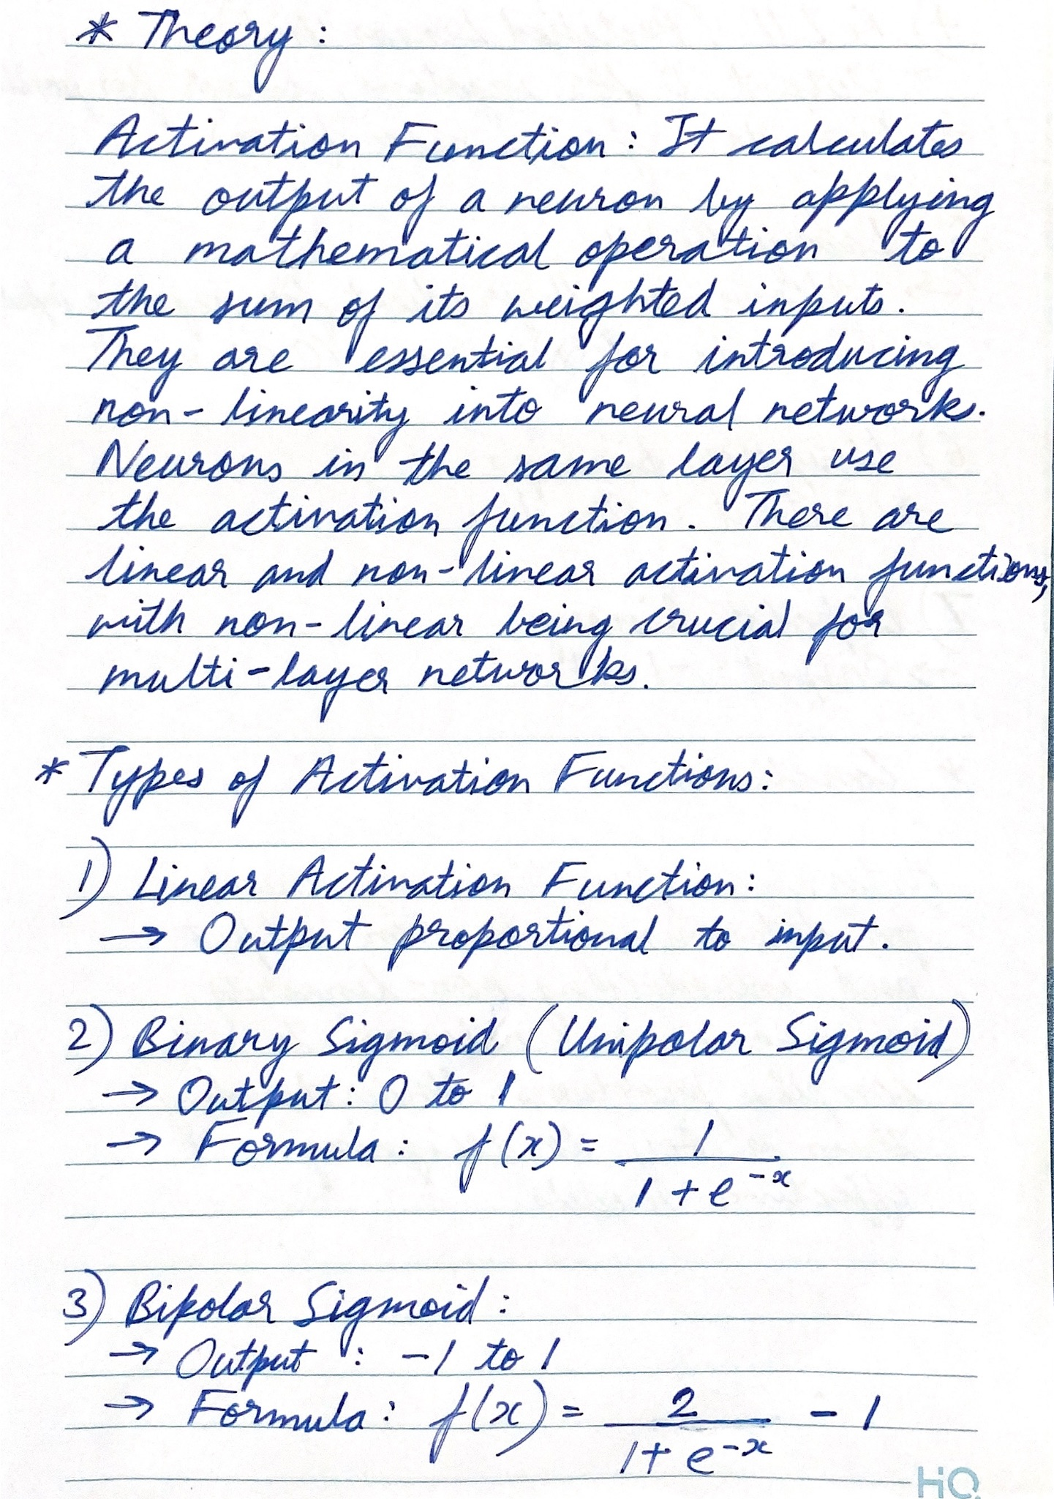

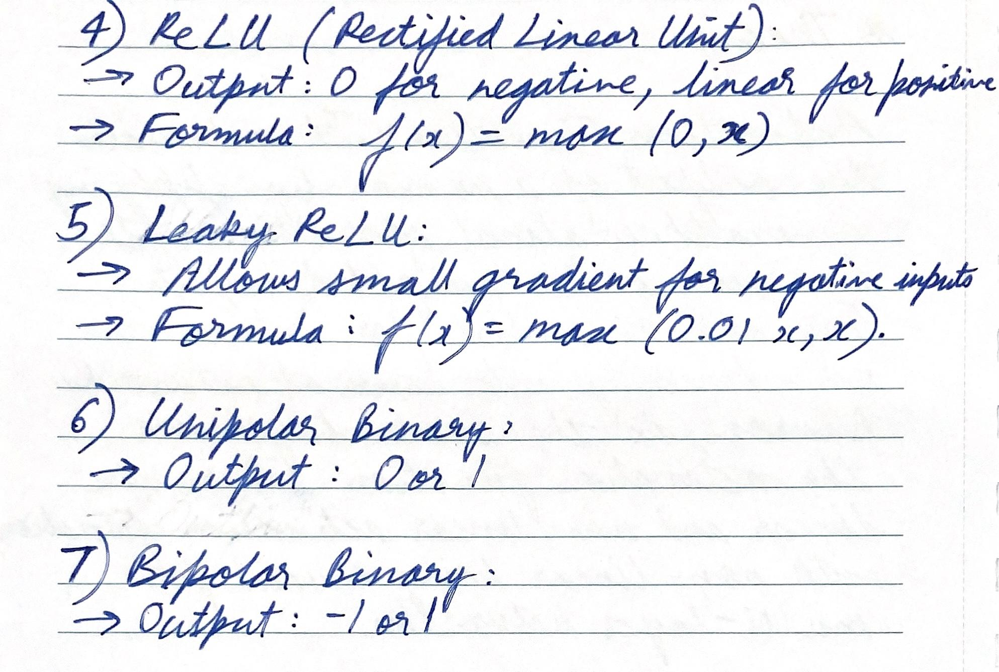

**Program:**

function Experiment_3()

while true

% Display menu options

fprintf('Select an activation function to plot:\n');

fprintf('1. Linear\n');

fprintf('2. Binary Sigmoid\n');

fprintf('3. Bipolar Sigmoid\n');

fprintf('4. ReLU\n');

fprintf('5. Leaky ReLU\n');

fprintf('6. Unipolar Binary\n');

fprintf('7. Bipolar Binary\n');

fprintf('8. Exit\n');

% Get user choice

choice = input('Enter your choice: ');

% Define the range of input values

x = -10:0.1:10;

switch choice

case 1

% Linear Activation Function

linear_activation = x;

plot_activation(x, linear_activation, 'Linear Activation Function');

case 2

% Binary Sigmoid Activation Function

binary_sigmoid_activation = 1 ./ (1 + exp(-x));

plot_activation(x, binary_sigmoid_activation, 'Binary Sigmoid Activation Function');

case 3

% Bipolar Sigmoid Activation Function

bipolar_sigmoid_activation = (2 ./ (1 + exp(-x))) - 1;

plot_activation(x, bipolar_sigmoid_activation, 'Bipolar Sigmoid Activation Function');

case 4

% ReLU Activation Function

relu_activation = max(0, x);

plot_activation(x, relu_activation, 'ReLU Activation Function');

case 5

% Leaky ReLU Activation Function

alpha = 0.01;

leaky_relu_activation = max(alpha * x, x);

plot_activation(x, leaky_relu_activation, 'Leaky ReLU Activation Function');

case 6

% Unipolar Binary Activation Function

unipolar_binary_activation = double(x >= 0);

plot_activation(x, unipolar_binary_activation, 'Unipolar Binary Activation Function');

case 7

% Bipolar Binary Activation Function

bipolar_binary_activation = double(x >= 0) * 2 - 1;

plot_activation(x, bipolar_binary_activation, 'Bipolar Binary Activation Function');

case 8

% Exit

disp('Exiting...');

break;

otherwise

disp('Invalid choice. Please select a valid option.');

end

end

end

function plot_activation(x, y, title_str)

figure;

plot(x, y, 'LineWidth', 2);

title(title_str);

xlabel('Input');

ylabel('Output');

grid on;

end

**Output Screenshot:**

